**ASK DON FARRELL …**

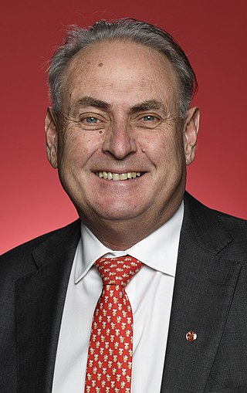

Donald Edward Farrell is an Australian politician and former trade unionist. He is a member of the Australian Labor Party (ALP) and has been Minister for Trade and Tourism and Special Minister of State in the Albanese government since 2022. He has served as a Senator for South Australia since 2016, after a previous term from 2008 to 2014. **But he is not the Governor General**.

Dear Senator Farrell,

I am an elector,

With your allegiance to the Union and the Labor Party and also my representative as a senator voting on the referendum in the senate, please advise why you have signed and issued the WRIT for the VOICE TO PARLIAMENT REFERENDUM, when it clearly states, in the Referendum (Machinery Provisions) Act 1984 Schedule 1 Form A, that the Governor General is the only signatory required by law in the name of the Monarch to sign and issue a referendum WRIT?

Thank you in advance for your immediate response by COB *[insert date].*

*[insert Date – Signature or Name – Address or email if sent electronically].*

Send to:

Email: [senator.farrell@aph.gov.au](mailto:senator.farrell@aph.gov.au)  
Phone: (08) 8231 8400  
Address: Level 5, 19 Gilles Street, Adelaide SA 5000  
PO Box 6338, Adelaide SA 500